Operation Management
Chelsea Tussey
Southern New Hampshire University

Operation Management
This paper provides an analysis of Nissan Moto Company in terms of its operation management functions and theories. The analysis also looks at the different techniques Nissan utilizes in its daily activities. Finny the paper will look at the sustainability efforts at Nissan. The Analysis of Nissan Motors is divided in three parts. Part one looks at Generation of Value through operational functions and competitive advantage. This part will also look at theories and techniques at Nissan Motors such as forecasting, supply chain risk analysis. Part 2 analysis will be an extension of theories and techniques and will focus on theories such as TOC and TQM which are utilized to ensure proper functionality at manufacturing companies. Part 2 will also look at data analysis using tools such as time-process map and cause-effect diagram to measure if the company is operating at functioning levels. The final part will look at the sustainability efforts taken by Nissan Motors.
Generating Value
Functions
A company uses operation management functions to generate value and provide products to its customers. The management functions of a company include planning, leading, organizing, controlling and staffing (Render, J2014). Nissan Motor has effectively applied these functions of operation management to generate value to their customers through provision of their products. The primary operation management at Nissan Motor is production of automobiles. In a competitive environment such as the automobile industry, there needs to be efficiency in the operation management functions so as to be considered successful. Nissan has proved that it understands the need for effective functions in order to generate value to its customers. During catastrophic events such as the tragic events of the 2011 Earthquake and Tsunami in Japan, Nissan has pre-planned and prepared for situations like these to handle the risks and avoid severe economic implications. The planning function ensured that in case of a disaster, the other function plants would continue manufacturing their products hence customers would not be affected. Prior to the 2011 events, Nissan pre-plan emergency response included priority based on prevention of follow on disasters, human life, business continuity and rapid disaster recovery. A Global Disaster Headquarters was created by the operations management team in order to ensure implementation of the Emergency plan response in case of disasters. This plan proved successful in the 2011 Earthquake and Tsunami events as it ensured business continuity at Nissan despite the catastrophic events.
Competitive Advantage
Competitive advantage in a company is unique features and products that a company has over its competitors. They involve; people, cost and differentiation. In the automobile industry, competition is high hence for a company to achieve a competitive edge, the managers need to make working choices regarding capacity and service design, process technology and location of operations. Nissan uses a just-in-time (JIT) technology to give a competitive advantage. This technology enables Nissan to produce specific vehicles and their components just in time to meet their demand. Consequently, this technology allows for low inventory levels hence keeping the production and storage costs down because there is no extra inventory that needs to be stored in a warehouse.
Service operations and manufacturing operations at Nissan
There are two types of organization operations at Nissan Motors; service operation and manufacturing operations. While these operations tend to go hand in hand, there are considerable differences between them. The main relationship is that without the service operations then the manufacturing operations would not function as well. This is because there is need for clients (service operations) in order to make sales of the products hence getting money from these clients to facilitate manufacturing of the products. One difference between them is that service operations works directly with the customers pertaining to the customer specifications such as motor accessories, color and quantity demanded. The manufacturing operations on the other hand involve producing the vehicles according to the specifications demanded by the customers.
Theories and Techniques
CPM and PERT
CPM and PERT are ways that enable project management teams prioritize their target goals. They involve diagrams that are utilized by the project managers to enable them find the best way to follow from the beginning of a project to the end of the project. The CPM method would be effective at Nissan particularly when planning the contingency plans at the Global Disaster Headquarter. It would be helpful when determining how to start and achieve the end goals of the project. ERT uses three estimates’ to enable a final destination in the process of planning. This method is useful in production process because there are many variables that can be included in the sequence such as materials, equipment, labor and maintenance. PERT can be useful in determining the starting and the ending time of the manufacturing process of a specific product.
Forecasting system
Forecasting plays an integral part in the business strategy of a company. Proper forecasting tools can be useful in predicting what products are highly demanded thus ensuring that there is enough in the inventory to ensure that demand by customers is met without strain (Forecasting. (N.D.). In the case of Nissan, utilizing forecasting tools s useful in helping predict which vehicles models are highly demanded by the customers hence making sure that there is sufficient inventory to meet the customer demands. There are five steps that need to be observed in order to have a successful forecasting method (Forecasting. (N.D.).
Step 1 includes defining the problem. This is the most critical a difficult step as it requires careful understanding of how to use the forecast and who will require the forecast. In this step, more data is collection is required then the data is input in a database and a forecasting is then set up. Step 2 requires statistical data and expertise of the people who gather the data and use the forecasts. Step three involves beginning a preliminary analysis usually done through graphical presentations to identify consistent trends and patterns. In step 4, there involves selecting and fitting models. The models are constructed using assumptions from known historical data that use more than one parameter to fit the model. Step 5 involves evaluation of the forecasting model. After a model has been selected and parameters estimated, the model is then useful in making forecasts. In the automobile industry, demographics and consumer trends weigh significantly on the production of new or improving the features of the existing vehicles. Therefore in case of Nissan, employing effective forecasting models would be useful in finding out if producing new concept vehicles would attract a customer base.
Supply Chain Risk
Nissan Motors has several critical factors that enable stronger capabilities in risk management and supply chain management. The most significant factors include, risk governance which includes risk management processes and structures, strategic alignment between the partners in the supply chain, alignment of activities across the value chain functions and appropriate flexibility and redundancy levels in the value chain.
Theory of Constraints (TOC)
The theory of constraints process identifies the process to follow in eliminating constraints in the manufacturing process. The key steps to the TOC include identification of constraints in the system. The single part in the system that limits the speed of achieving the intended goals in this very first step.
The second step is to exploit the identified constraint in the exploitation of the constraint, quick improvements made on the weak parts of the system. The existing resources are used to get the best possible from the part that denoted weaknesses. The next step is to subordinate and synchronize the constraint to ensure that, with the resolutions made the error no longer exists. In the synchronization, the part aligns with the rest in the system. The next step is to elevate the constraint if the issue is found to exist still. In this step, further remedies are the sort to address the issue constraints such that the system performs well (Cox III & Schleier, 2010). Lastly, the whole process may be repeated. The system improvement is a continuous process. Hence all other parts continue to be troubleshot, to ensure no other constraint is imminent.
The Nissan Company can apply TOC processes in the post-disaster company recovery. Since the disaster was an emergency, the TOC process is embraced in restarting the company operations in the aftermath. By applying the TOC protocols, the company would have the advantage of resolving the major issues undermining the day-to-day operations of the firm. The TOC process is of the essence, in managing non-emergency cases, given the room to scan the various units to determine any redundancy.
Total Quality Management
Total Quality Management refers to practices that ensure proper management of an organization so that is successful pertaining to the products and services that are especially important to customers (Schmidt, 2013). Edwards, Deming, a Quality expert came up with seven concepts that when properly utilized, produce an effective TQM tools. The concepts include: Six Sigma, bench marking, just-in-time, empowerment of employees, continuous improvement and TQM tools knowledge (Schmidt, 2013). There are numerous tools that are available to assist operations managers with TQM in running their daily activities. Such tools include pie and bar charts, tree diagrams, focus groups and PDCA, and relations diagrams.
The total quality management practices are of the essence in handling the situation of the case study for the Nissan Company. For example, the employees in the company ought to be engaged sufficiently in resolving the standing challenges (Dahlgaard et al., 2008). The incorporation of the employees in the making of the solutions is critical in realizing success and full operation of the firm. Further, every decision made, ought to be based on facts as opposed to opinions. The use of facts is of the essence especially in financial matters and people issue management after the disaster.
Another critical application of the total quality management principles is the deployment of a customer-centered approach. During the disaster cars were destroyed across Japan. As such, the company needs to have the customer needs at the heart of every decision made. Further, a mutually beneficial supplier relationship are significant in the case study. The relations ought to be mutually beneficial, given the hard financial times the company underwent as results of the disaster. Friendly trade agreements are crucial in the restarting of the company that was on the verge of extinction. An approach of continuous improvement should also be embraced, as the company maneuver through the hard economic times. A continuous improvement process is embraced last, as the company tries to keep in track progressive development and full recovery from the losses of the disaster.
Data Analysis
Cause and Effect Diagram
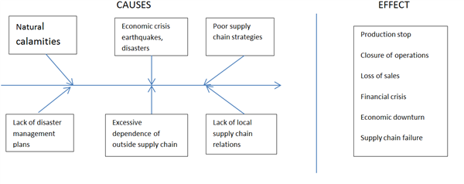
The natural disaster in Japan had affected every major automobile companies. The major issue between all of them was on closing the production plants. These caused them to stop the materials to the rest of the world. With Nissan, able to implement a strategy that was able to help with the supply chain. The chart allows for you to see the issues that caused the slowdown and how they handled the lack of materials.
Time Function Map
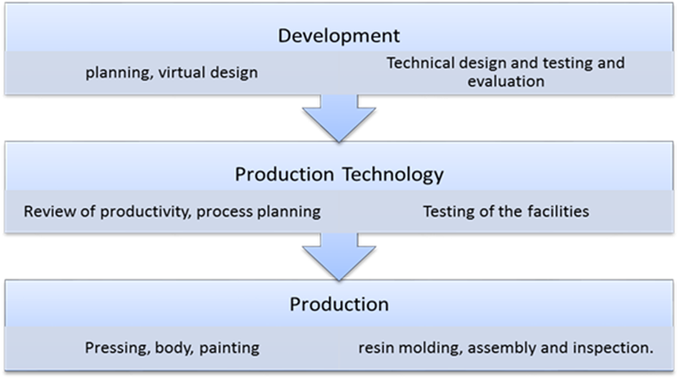
The values map cannot only evaluate the company’s project now but also in the future as well. The time-function map is useful to operations managers as it provides the OM with a time line of how long a project or process will take and provides a guideline of the point where a project should be at a given time. The time-function map shows a timeline from the time of building a concept by the R& D team to the time of assembling and finally to the dealerships for sale.
Suppose Nissan is looking for a new location to establish its new plant, it will need to do further analysis to weigh on pros and cons of that area. Suppose it is looking between Mexico and Columbia the data analysis below will be used in determining which location is appropriate.
Factor Weight Mexico City Columbia, SC
Political Risk .25 70 80
Transportation Costs .20 40 90
Labor Productivity .20 85 75
Rental Costs .15 90 55
Labor Costs .10 80 50
Taxes .10 90 50
The best location for the new manufacturing plant for Nissan would be Mexico City. Based on the sum of the weighted values labor productivity, political risk and the transportation costs are weighted the highest. However, the political risk in Mexico is lower than that of Columbia and the transportation costs are a significantly smaller than those of Columbia. Notably however, the labor production cost in Mexico is slightly higher than that of Columbia. While these three factors take up the significant portion in the weighted sum, compared to Columbia, Mexico scores a better value hence it is best suited to plant a Nissan manufacturing plant.
Nissan Company has been using some strategies to try to manoeuvre through challenging times. Among them are the just in time and Toyota production system. Each of the systems has got its strengths and drawbacks, which should be monitored, carefully for optimal results.
Just – in – time
This theory is aimed at reducing stock levels to the bare minimum. It operates with the idea that something should be obtained when actually needed. For it to apply there needs to be close coordination between the different units and departments in an entity. It would require proper agreements with suppliers and also their closer proximity. Raw materials are not stocked but moves from one stage to another when needed (Aycock, 2003).
Advantages of using JIT
Nissan can enjoy the following benefits by using JIT:
Lower cost of production – As inventory is reduced to the bare minimum, costs associated with holding stock reduces also. These costs can be the opportunity cost of the funds tied up in stock, cost of insurance, rent payment, security to the inventory and also obsolescence costs among others (Gartenstein, 2019).
- Reduction in cash cycle – Nissan can also reduce its cash cycle by adopting JIT. This is possible since stock does not tie up cash and expenses on inventory are incurred immediately the inventory is needed reducing time.
- Reduced risk exposure – Nissan would suffer very little stock damage due to the Tsunami if the stock levels were very low. Also there can be fire out breaks and theft all of which would have very little impact if stock levels are maintained at the bare minimum.
Disadvantages of using JIT
- System failure – JIT operates well with the assurance of closer coordination of the different entities involved. In case of failure by one of the entity, the whole process and system collapses. This can happen due to failure on the side of supplies, breakdown of machines affecting transfer of work in progress to the next level and also misinformation between any of the entities or departments (Gartenstein, 2019).
- Increased dependency – JIT increases dependency between the different units, which then makes it very hard for a unit to survive without the other (Gartenstein, 2019).
- Exploitation – Suppliers can sometimes exploit the Nissan company when they know they use JIT by demanding for payments before supplies or even increase in prices as they are aware of the urgency in Nissan orders due to JIT
- Cost implication – JIT may sometimes come with hidden costs
Toyota production system
This is usually an advancement of the Just in time system. This system can in fact be seen like it was developed to perfection just in time philosophy. It operates with the principles of:
- Reduction of set up times for every new production run
- Reducing production batch sizes
- Proper sourcing of supplies
- Proper maintenance of equipment
- Treating suppliers as partners
- Use of just in time or pull production technique
The advantage of this system are similar to those of the Just in time technique like cost reduction, reduction in risk exposure and better quality products and with the main disadvantage of system failure if the flow of information and materials is distracted (Monden, 2011).
Lean production
Lean production is another advancement of both JIT and TPS. It basically emphasises on value creation and majors on what adds value and at the same time discards what does not create value. It is aimed at reduction of waste. It brings the advantages of cost reduction, ensuring smooth operations and ensures product availability among other advantages. The major disadvantage of this system is that it leaves very little room for error and is less flexible. An occurrence like machine failure can easily stall the whole system. This would lead to failure in meeting customer orders which then complicates the whole thing (Krafcik, 1988).
All the three production methods are interrelated with each being a perfection of the other. They all have a lot of similarities like reduction of waste, emphasis on the acquisition of materials only when needed, reduction of inventory levels and focus on the customer. Both TPS and lean system operate with the basic principles of JIT.
Sustainability
Triple Bottom Line (TBL)
The TBL consists of three concepts, people, profit and the planet. It is effective in measuring the social, financial and environmental performance of an organization over a specific period of time. Nissan can use more current systems like the triple bottom line (TBL) to boost its space in the manufacturing sector and be more appealing to the communities. Nissan closely links its CSR activities and business operations to establish a corporate management that aligns the TBL goals of sustainable profits, company growth and sustainable development of people and environment (Line, 2009). This approach aims at going beyond economic value and recognizing both social and environmental impact.
ISO 14000
ISO 14000, deals with the management of how production processes affect the environment (Poksinska, Jörn Dahlgaard, & Eklund, 2003). This ISO standard would help Nissan Company be conscious of the environment and can also win some reputation credits from this adherence. It can use methods with the least negative effects to the environment. This can be achieved by reducing pollution in their facilities and proper treatment and disposal of industry effluents. Nissan has taken several measures towards increasing CSR in line with the ISO 14000. In 2010, Nissan established the Nissan Green Program as part of its environmental action plan. Nissan aims to continuous strengthening its environmental management through provision of models that have high environment performance or rather zero emission. This will be achieved through provision of 100% electric vehicles that are designed to achieve a class-leading fuel economy and next generation eco-technologies. Nissan can incorporate CSR practices into their operations by utilizing methods such as TPS, Lean operations and JIT hence cutting down on waste. JIT method can help cut down on storage space hence help the environment because there will be no need to clear land for establishing a new building.

References
Aycock, J. (2003). A brief history of just-in-time. ACM Computing Surveys (CSUR), 35(2), 97-
113.
Cox III, J., & Schleier, J. (2010). Theory of Constraints Handbook. McGraw-Hill.
Dahlgaard, J. J., Khanji, G. K., & Kristensen, K. (2008). Fundamentals of total quality management. Routledge.
Driskill, G. W. (2018). Organizational culture in action: A cultural analysis workbook. Routledge. Zygmunt,.
Forecasting. (N.D.). The Basic Steps in a Forecasting Task. Retrieved 03 21, 2015. From Otexts: https://www.otexts.ord/fpp/1/6
Gartenstein, D.(2019, Jan 28). Advantages & Disadvantages of Just-In-Time Inventory. Retrieved from: https://smallbusiness.chron.com/advantages-disadvantages-justintime-inventory-21407.html
Krafcik, J. F. (1988). Triumph of the lean production system. MIT Sloan Management
Review, 30(1), 41.
Line, T.B. (2009, Nov 17). Triple Bottom Line. The Economist.
Retrieved from: https://www.economist.com/news/2009/11/17/triple-bottom-line
Monden, Y. (2011). Toyota production system: an integrated approach to just-in-time.
Productivity Press.
Poksinska, B., Jörn Dahlgaard, J., & Eklund, J. A. (2003). Implementing ISO 14000 in Sweden:
motives, benefits and comparisons with ISO 9000. International Journal of Quality & Reliability Management, 20(5), 585-606.
Render, J.H. (2014). Operations Management (11th ed.). (D. Battista, Ed). Pearson Education Inc.
Schmidt, W., & Simchi-Levi, D. (2013). Nissan Motor Company Ltd.: Building Operational Resiliency. MIT Sloan management review, 13-149.

